Category: Easy

Competition: CSI KJSCE’s Code in X

Question:

The mechanical engineering department of KJSCE was developing a water purification system. Unfortunately their volume rate of flow measurement system wasn’t capable of measuring very large volumes of water provided at the input. A water aeration device called trickle water aerator was being used by the system so the team decided to perform a measurement in between the aerator as it divided the flow and then somehow compute the total rate of flow. Help the team calculate total input flow rate by making a program for the same.

The filter is made of special pyramids that divide flow into two streams having 60% and 40% volumes of total respectively.

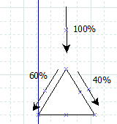

A filter has depth from 0 to d and the ith level has i+1 outputs:

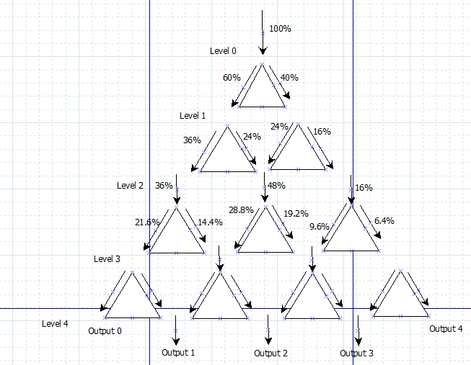

Inputs:

Level number

Output number

Flow rate

Constraints:

Level number: integer from 1 to 1000

Output number: integer from 0 to 1000

Flow rate: fraction ranging from 0 to 10^6 with 3 decimal accuracy at least.

Try these inputs:

|  |  |
| --- | --- |
| **Input** | **Output** |
| 1 0 60 | 100 |
| 1 1 20 | 50 |
| 2 0 9 | 25 |
| 2 1 12 | 25 |
| 2 2 2 | 12.5 |
| 3 0 21.6 | 100 |
| 3 1 4.32 | 10 |
| 3 2 144000 | 500000 |
| 3 3 0.064 | 0.1 |